**Decentralized and Centralized Smart Game Objects using the Ethereum Blockchain**

**Kevin Buckley**

Initial Draft: 8/22/2017

**Table of Contents**

Introduction 3

Setting the Stage 4

What you need to Know about Ethereum 4

Digital Asset Ownership in the Video Game Industry 4

Costs of Doing Business 5

Potential for Profit 5

SGO Architectures 6

Smart Game Objects (SGOs) 6

Decentralized architecture 6

Centralized Architecture 8

Work in Progress 10

SGO Tech 10

References 11

Introduction

In his blog post of the same name, Jones (2017) introduces the concept of smart game objects (SGOs), as digital items that can be transferred from one owner to another using the Ethereum smart contract technology. Jones argues that there is interest in digital asset ownership by game owners, due to the amount of time and, sometimes, fiat (real world) currency spent developing these assets. Also, this whitepaper argues that by adopting a centralized framework for these SGOs there are potential benefits for game developers as well.

Setting the Stage

What you need to Know about Ethereum

There are certainly much better resources available that discuss both blockchain technology and the Ethereum blockchain in detail. For the purposes of this discussion there are a few key elements that the reader should be aware of (if they aren’t already) According to the official Ethereum (2017) website:

“Ethereum is a **decentralized platform that runs smart contracts:** applications that run exactly as programmed without any possibility of downtime, censorship, fraud or third party interference.

These apps run on a custom built **blockchain, an enormously powerful shared global infrastructure that can move value around and represent the ownership of property.”**

Simply put, Ethereum smart contracts allow for the automated transfer of digital assets in a secure, transparent, and efficient manner. With Ethereum you get all of the benefits of a public distributed ledger as well as the ability to deploy centralized automated code that can be used to create, manipulate, and transfer ownership of SGOs.

Digital Asset Ownership in the Video Game Industry

In the current climate, ownership of character created content, such as characters developed, items created, and even environmental maps remain the property of the game companies. There is legal precedence set in the 1998 case Micro Star v. Formgen, Inc., which (in the U.S.) finds consumer created content as derivative work of the underlying property and therefore owned by the original creator (Kelly & Plassaras, 2015). With a market valuation of $91 billion dollars, it is easy to understand why game companies aren’t eager to give away what they consider their property (Takahashi, 2016).

Costs of Doing Business

**[Add section discussing Gas and associated costs for using Ethereum]**

Potential for Profit

Spending fiat currency on digital items in gaming has come a long way from the black market transactions with “gold farmers,” or illicit exchanges of fiat currency for digital currency. Even mainstream games like World of Warcraft (Activision/Blizzard) have adopted the concept of micro-transactions (MTX) for actions like character transfers and renaming. In 2013 Activision brought in $213 million in MTX revenue, and they didn’t even break the top five. The top two games, Crossfire and League of Legends are free to play but have generated $957 and $624 million, respectively, in revenue in 2013 (Grubb, 2014). These numbers make it hard to argue against the MTX approach for games. If anything, these examples highlight the willingness for consumers to pay for content, customization, and portability.

**[Extend discussion and make case for Ether surcharges for object transfer, consumption, etc.]**

SGO Architectures

Smart Game Objects (SGOs)

Expanding upon Jones’ (2017) discussion of SGOs, we present a notional depiction of the concept as a digital element that contains several components in Figure 1:

* A unique identifier
* A passcode or key that allows for the object to be accessed and/or modified
* One or more attributes such as object dimensions, special qualities, or game-specific data.

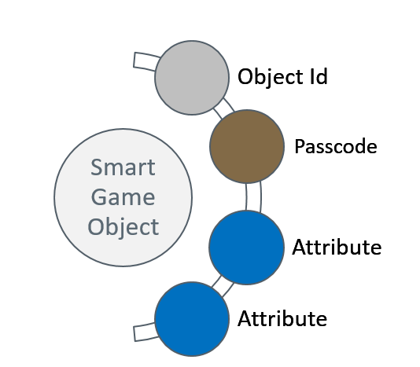

*Figure 1.*Smart Game Object Model

Decentralized architecture

The decentralized SGO architecture relies on the idea that once SGOs are created, they remain constant. SGO attributes do not change, representing a finite digital object. This object is similar to a Token in the context of the blockchain world and, as such, can be bought, sold, traded, or consumed. In this architecture, consuming the token is equivalent to using that token in an application or game to create a local instance of that object. In the decentralized model, the original SGO becomes the parent object. Once a local instance of the SGO is created, it becomes a child object, inheriting some or all attributes from the existing object and potentially adding new attributes as needed by the local application. Figure 2 illustrates the parent-child relationship.

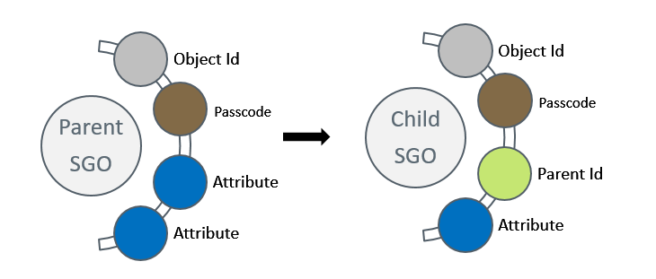

*Figure 2.* Parent-Child SGO Relationship

**Sharing in a decentralized architecture.** Sharing in a decentralized architecture is not limited to the original SGO. If an application makes a child SGO available for consumption, that SGO can be consumed by another application, extending the lineage of that SGO to what could be considered a grandchild of the original object. By adopting a standard SGO format, applications can easily integrate with one another by sharing objects. Figure 3 illustrates the sharing relationship in a decentralized SGO architecture.

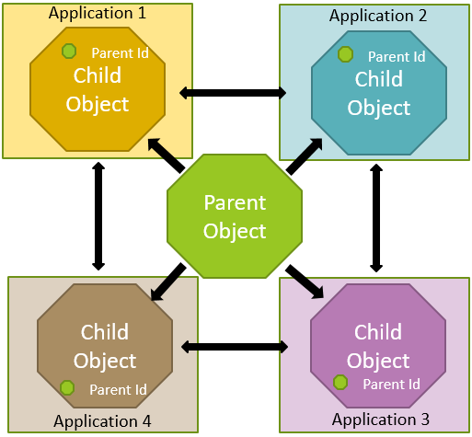

*Figure 3.* Sharing in a Decentralized SGO architecture

Centralized Architecture

Unlike the static SGO used in the decentralized SGO architecture, a centralized approach requires that the SGO be a dynamic object that can be modified by external entities. This allows for the SGO to continually evolve and contain attributes that are both publicly available for all applications and reserved for private use by a specific application. Due to the dynamic nature of a centralized SGO, the resultant smart object is better viewed as a layered entity, as shown in Figure 4.

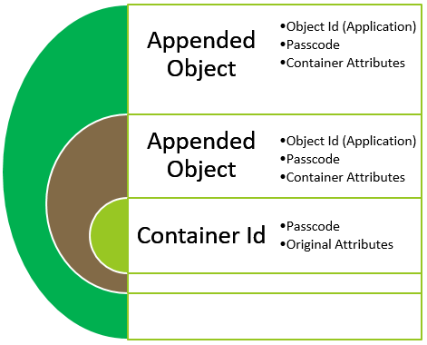

*Figure 4.* Centralized SGO

**Sharing in a centralized architecture.** Sharing in a centralized architecture is much simpler than in a decentralized architecture. External applications can access attributes that exist within the SGO and, with permission, add and modify attributes that are required by that application. There is no need for integration paths between external applications because the access to application-specific attributes can be granted via controls in the SGO. Figure 5 illustrates the sharing relationship in a centralized SGO architecture.

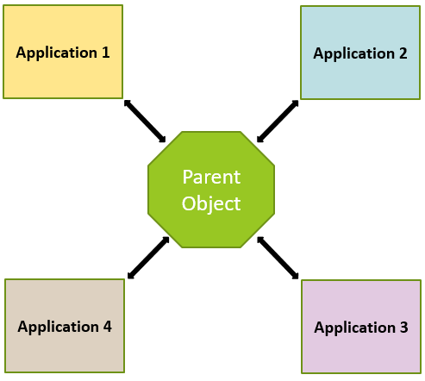

*Figure 5.* Sharing in a Centralized SGO architecture

Work in Progress

SGO Tech

* Tokens vs Smart Contracts
* How can SGO be modified?
* Tokens
  + Data in the blockchain vs external storage
    - local vs centralized
* Smart Contracts
  + Can they be dynamically updated?
  + How to add attributes to a smart contract variable
    - Array data
    - Hash data

****References****

Ethereum. (2017). Build unstoppable applications. Retrieved from <http://www.ethereum.org>

Grubb, J. (2014). 10 online PC games that made more than $100M in microtransaction sales last year. Retrieved from <https://venturebeat.com/2014/01/20/10-online-pc-games-that-made-more-than-100m-in-microtransaction-sales-last-year/>

Jones, M. (2017). Smart Game Objects. Retrieved from <https://medium.com/8-circuit-studios/smart-game-objects-45894492f369>

Kelly, J., & Plassaras, N. (2015). Copyrighting player-generated content in video games. Retrieved from <https://venturebeat.com/2015/01/07/copyrighting-player-generated-content-in-video-games/>

Takahashi, D. (2016). Worldwide game industry hits $91 billion in revenues in 2016, with mobile the clear leader. Retrieved from <https://venturebeat.com/2016/12/21/worldwide-game-industry-hits-91-billion-in-revenues-in-2016-with-mobile-the-clear-leader/>